Midterm Name: ______________________

Read and answer all questions, correctly! You may use your book and any class notes.

- A student has created a database consisting of a single table. The names of the table fields are given below.
EmpId | EmpName | EmpPhone | JobTitle | Salary | HireDate | MgrName | DeptNo | DeptName

  - What problems are there with the above table layout? Assume that all fields have been appropriately defined.

The table contains duplicate data in DeptNo, DeptName, and MgrName. If a DeptName or MgrName changes, multiple rows must be updated. The EmpName should also be broken out into multiple fields.

  - Redesign the database to eliminate the problems mentioned in part a.

Create a Dept Table with DeptNo and DeptName
Divide the EmpName into three fields: EmpFName, EmpMI, EmpLName
Change MgrName to MgrId in the Emp Table

- A video store has created the following table as part of its database. What problems do you see with the given table design? Assume that all fields have been appropriately defined.

Title | Producer | Director | Actor | Actress | SupportingActor | SupportingActress | Genre

The table may contain many NULL values, and is limited to at most one actor/actress etc. per movie. This table contains the data for multiple entities.
Examine the following relational model and answer the questions below.
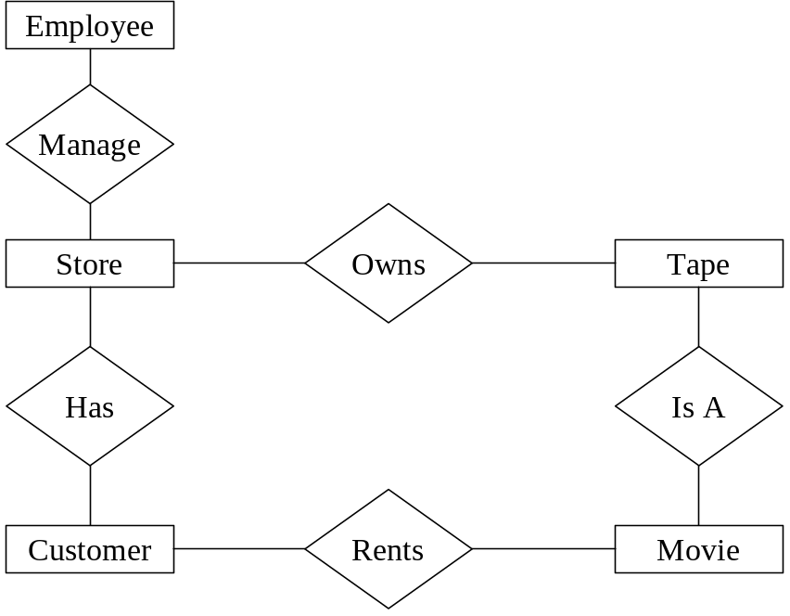

  - One of the relationships above goes between the wrong two tables. Identify and correct the relationship.

Rents should go between Customer and Tape

  - Mark all relationships as 1:1, 1:M, or M:N in the diagram above.

Manage is 1:1
Has is 1:M (Store to Customer), or M:N.
Owns is 1:M (Store to Tape).
Is A is 1:M (Tape to Movie).
Rents is M:N.

  - Identify all tables that must be created in order to implement many-to-many relationships.

The Rents relationship must be turned into a table.

  - For each table in the database, including those listed in part c, define a primary key.

Employee – EmpId
Store – StoreId
Customer – CustId
Tape – TapeId
Movie – MovieId
Rents – CustId, TapeId, Date

  - For each table in the database, define all foreign keys.
- Use the following relational model to create queries

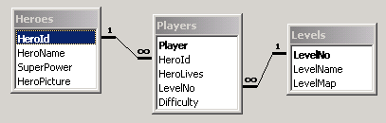

- List the names of all possible heroes along with their super powers.

SELECT HeroName, SuperPower
FROM Heroes;

- List the names of all players and the heroes that they play.

SELECT Player, HeroName
FROM Players, Heroes
WHERE Players.HeroId = Heroes.HeroId;

- List the names of the levels, in order, from lowest to highest.

SELECT LevelName
FROM Levels
ORDER BY LevelNo ASC;

- List the most popular (most played) hero.

CREATE VIEW CountOfHeroes
SELECT HeroId, COUNT(HeroId) AS HeroCount
FROM Players
GROUP BY HeroId;

CREATE VIEW MostPopularHero
SELECT HeroId
FROM CountOfHeroes
WHERE HeroCount = (SELECT MAX(HeroCount)
FROM CountOfHeroes);

SELECT HeroName
FROM Heroes, MostPopularHero
WHERE Heroes.HeroId = MostPopularHero.HeroId;

- List the number of players playing each hero, along with the average level that players are on for that hero.

SELECT Count(Player), HeroName, AVG(LevelNo)
FROM Players, Heroes
WHERE Players.HeroId = Heroes.HeroId
GROUP BY Players.HeroId;

- List the player who has reached the highest level on difficulty 'hard'.

SELECT Player
FROM Players
WHERE Difficulty = 'Hard' AND
LevelNo = (SELECT MAX(LevelNo)
FROM Players
WHERE Difficulty = 'Hard')

